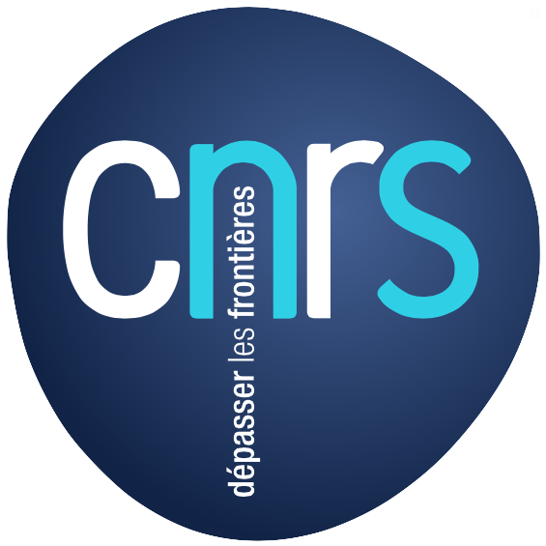
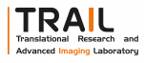
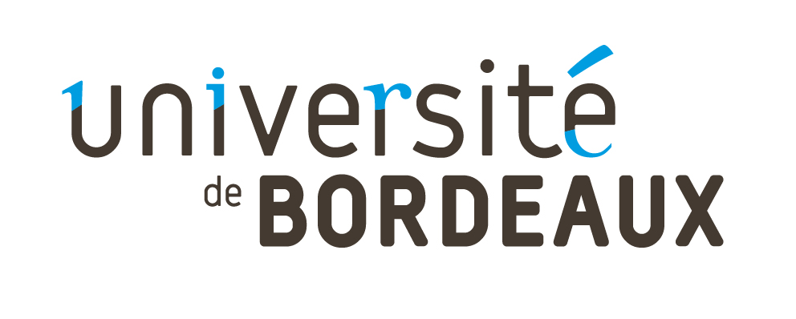

Ex vivo and in vivo ¹³C-NMR spectroscopy of the rat brain to explore metabolic modifications during brain activation

Doctoral fellowship
A 36-month doctoral fellow position is available at the RMSB Center, in Bordeaux (starting September/October 2015). This position is funded by the Labex TRAIL (Cluster of excellence, Translational research and advanced imaging laboratory). The main objective of this project is to explore brain metabolism, and more particularly to decipher metabolic interactions between neurons and astrocytes. Indeed, if glucose is considered as the main brain energy substrate, increasing evidence now suggest that lactate, coming from astrocytes, could be a supplementary and very efficiency energetic fuel for neurons, especially during brain activation, as well as during hypoxia.

Location
Resonance Magnetic in Biological System (RMSB) Center, UMR5536 (CNRS/Université de Bordeaux), 146 rue Léo Saignat, 33076 Bordeaux, France.

Project
- To perform ex vivo NMR spectroscopy after injection of ¹³C- labeled substrate. NMR will be performed on brain biopsies using a HRMAS probe (Bruker 500MHz) to quantify brain ¹³C-metabolites during brain activation, both on control and genetically modified rats.
- To optimize the ¹H/¹³C-NMR spectroscopic sequence parameters to detect [3-¹³C]metabolites in the rat brain, in a 3x3x3mm voxel.
- To model the database for LCModel, a tool for in vivo spectrum analysis: LCModel (Provencher, NMR Biomed. 2001;14-4) allows automatic quantification of in vivo NMR spectra.
- To perform in vivo NMR spectroscopy after injection of ¹³C- labeled substrate. The final aim will be to perform localized ¹H/¹³C-NMR spectroscopy and analyze the spectra using LCModel to detect brain ¹³C-metabolites during brain activation, both on control and genetically modified rats.
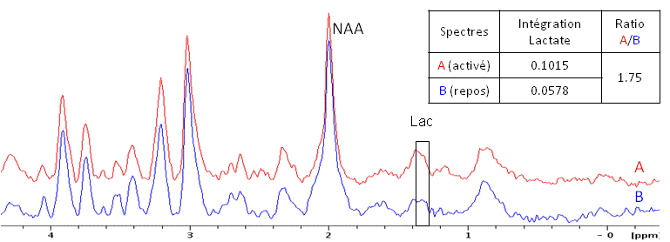
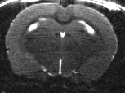
Candidate profile (at least one of the following skill)
- Knowledge in brain metabolism
- Knowledge in NMR spectroscopy (LCModel)

Place, duration and remuneration
- 36 months contract, starting from September/October 2015.
- net salary: 1.530 € per month.

Application and contacts
Motivation letter and CV should be send to: akb@rmsb.u-bordeaux2.fr

